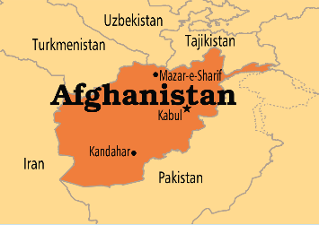 | 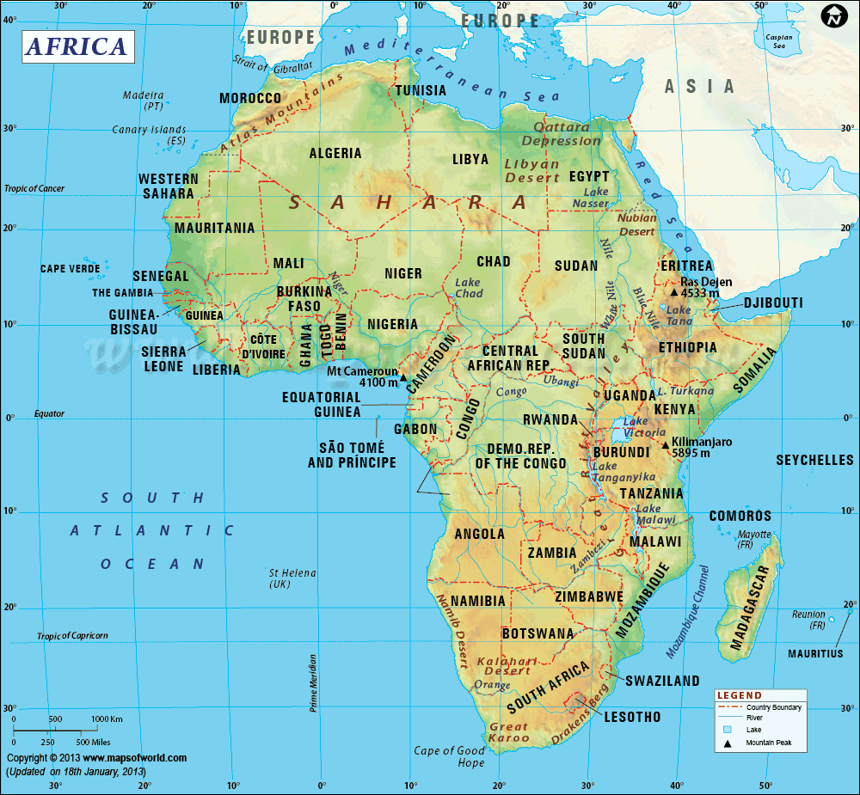 | 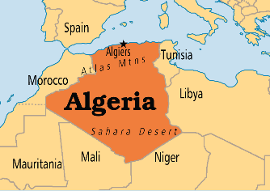 | 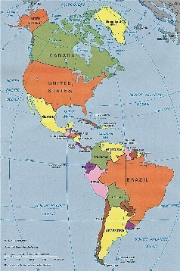
Afghanistan | Africa | Algeria | Americas
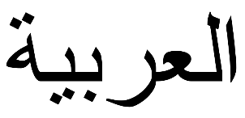 | 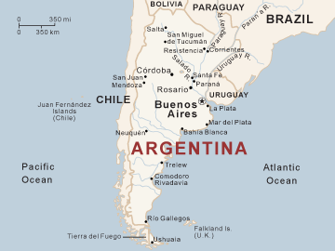 | 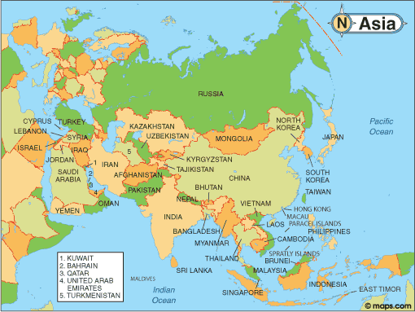 | 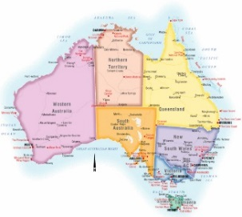
Arabic | Argentina | Asia | Australia
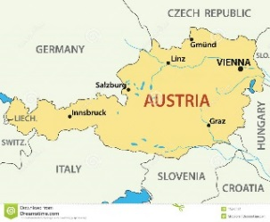 | 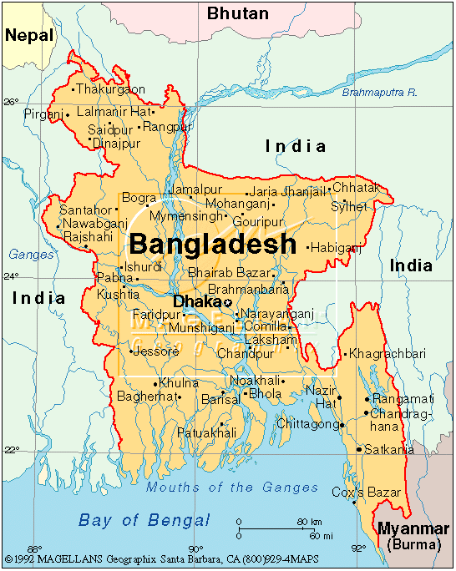 | 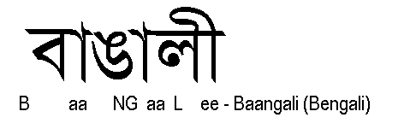 | 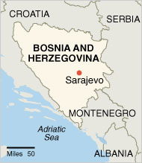
Austria | Bangladesh | Bengali | Bosnia and Herzegovina

Americas  972 million | Algeria  40,400,000 | Africa  1.1 billion | Afghanistan  27,101,365
Australia  23,841,800 | Asia  4.3 billion | Argentina  43,131,966 | Arabic  295 million
Bosnia and Herzegovina  3,791,622 | Bengali  205 million | Bangladesh  158,324,000 | Austria  8,579,747

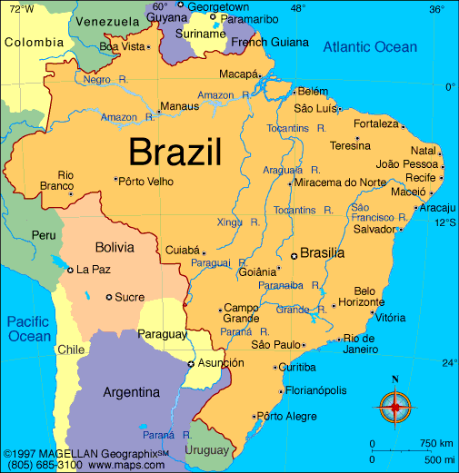 |  | 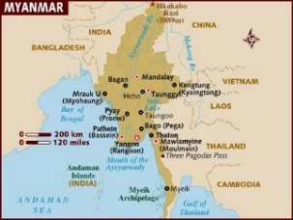 | 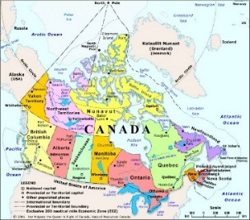
Brazil | Buddhism | Burma | Canada
 | 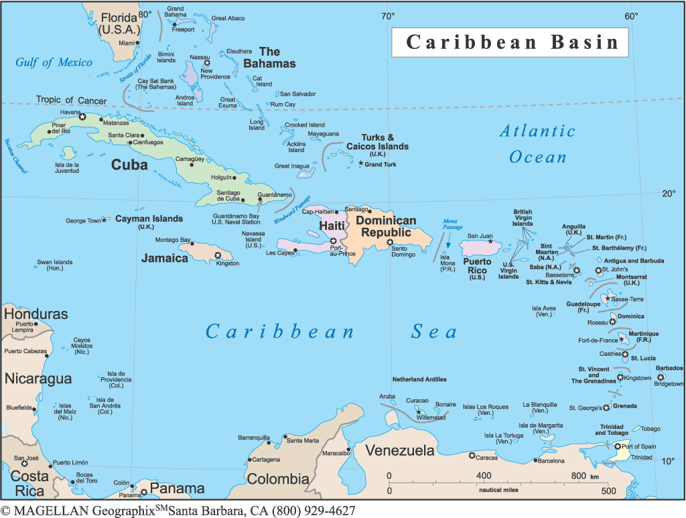 | 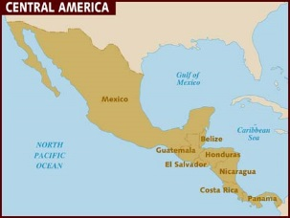 | 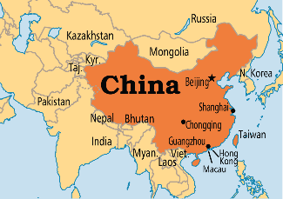
Cantonese | Caribbean | Central America | China
 |  | 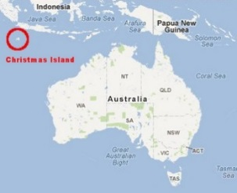 | 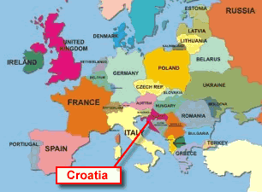
Chinese traditional religion | Christianity | Christmas Island (Australia) | Croatia

Canada  35,702,707 |  | Burma  51,419,420 | Buddhism  376 million |  | Brazil  204,302,000
China  1,369,810,000 |  | Central America  167 million | Caribbean  42 million |  | Cantonese  59 million
Croatia  4,267,558 |  | Christmas Island (Australia)  2,072 | Christianity  2.2 billion |  | Chinese traditional religion  394 million
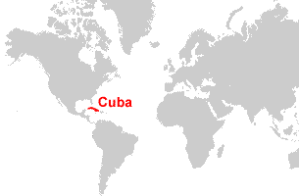 | 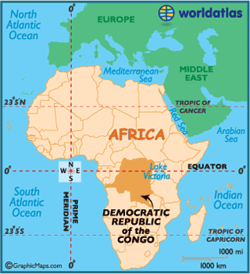 |  |  | 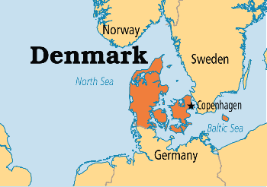 |  | 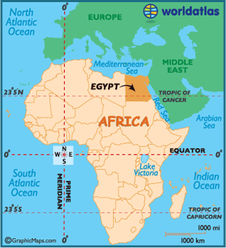
Cuba | Democratic Republic of the Congo |  |  | Denmark |  | Egypt
 | 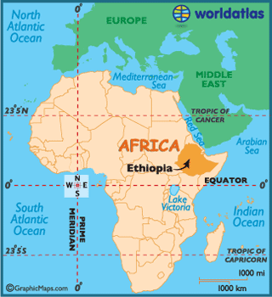 |  |  | 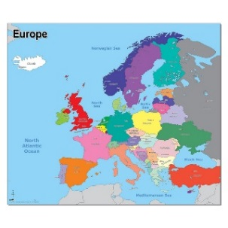 |  | 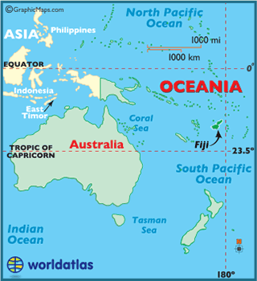
English | Ethiopia |  |  | Europe |  | Fiji
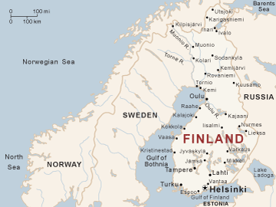 | 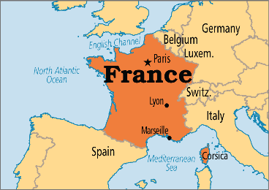 |  |  |  |  | 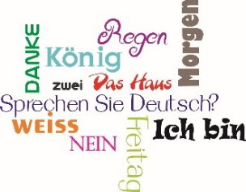
Finland | France |  |  | French |  | German

Egypt  88,505,400 | Denmark  5,668,743 | Democratic Republic of the Congo  71,246,000 | Cuba  11,210,064
Fiji  859,178 | Europe  742 million | Ethiopia  90,076,012 | English  360 million
German  89 million | French  74 million | France  66,121,000 | Finland  5,478,002
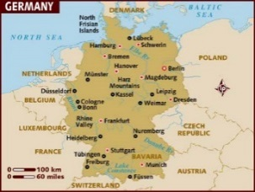 | 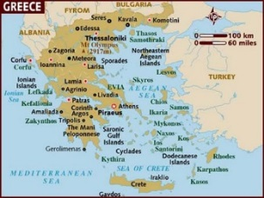 | 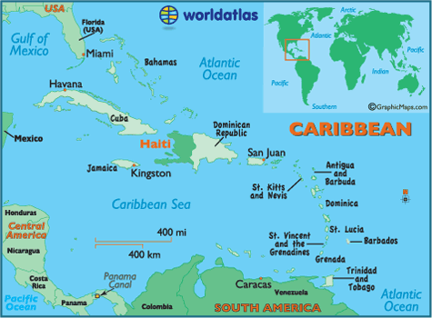 | 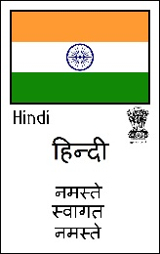
Germany | Greece | Haiti | Hindi
 | 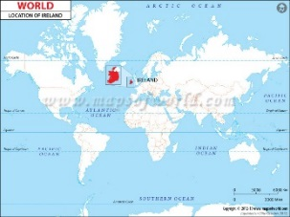 | 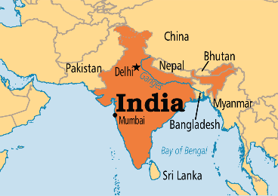 | 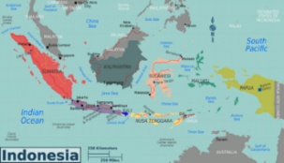
Hinduism | Iceland | India | Indonesia
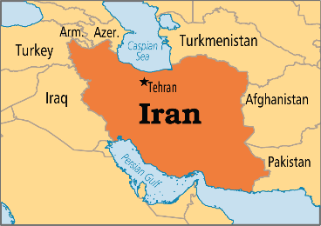 | 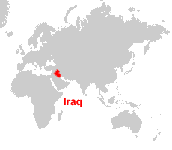
Iran | Iraq | Ireland | Islam

Hindi  310 million | Haiti  10,911,819 | Greece  10,816,286 | Germany  81,083,600
Indonesia  255,461,700 | India  1,271,110,000 | Iceland  329,740 | Hinduism  1 billion
Islam  1.6 billion | Ireland  4,609,600 | Iraq  36,004,552 | Iran  78,332,000

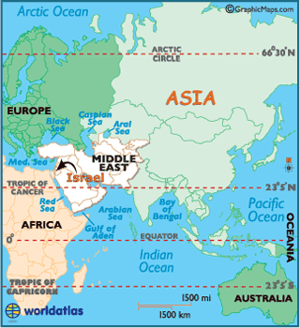 |  | 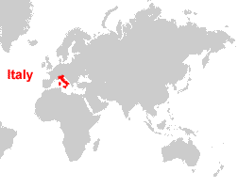
Israel | Italian | Italy | Jainism
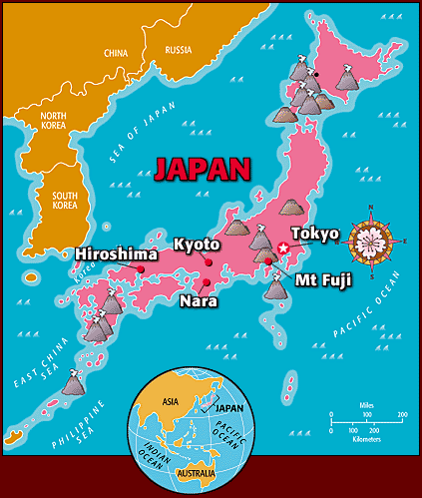 | 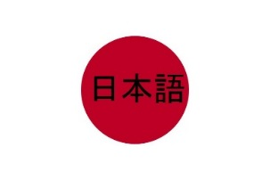 | 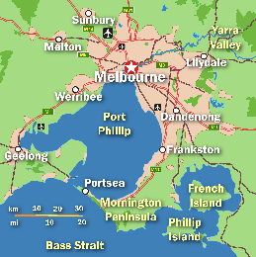 | 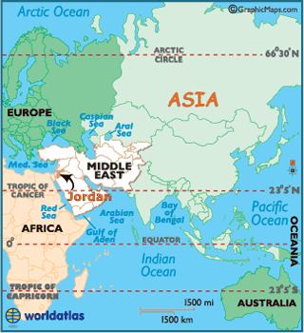
Japan | Japanese | Melbourne | Jordan
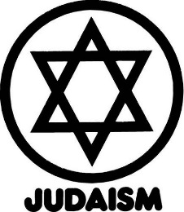 | 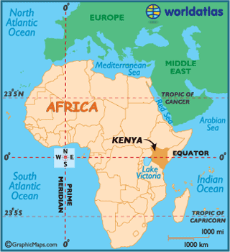 | 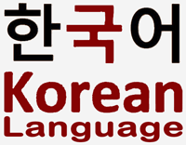 | 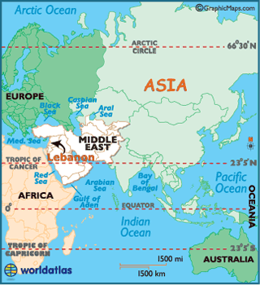
Judaism | Kenya | Korean | Lebanon

Jainism  4.2 million | Italy  60,788,845 | Italian  59 million | Israel  8,345,000
Jordan  6,728,890 | Melbourne  4 million | Japanese  128 million | Japan  126,910,000
Lebanon  4,104,000 | Korean  76 million | Kenya  46,749,000 | Judaism  14 million

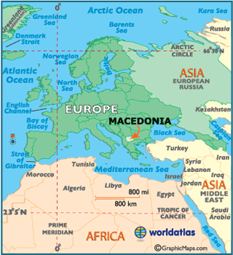 | 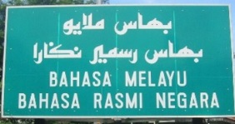 | 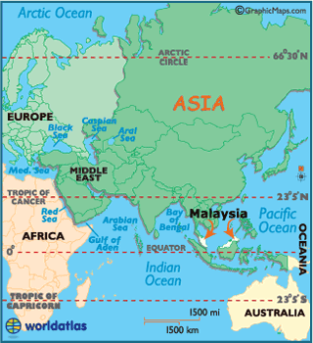 | 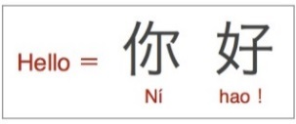
Macedonia | Malay/Indonesian | Malaysia | Mandarin
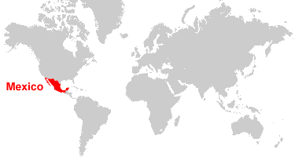 | 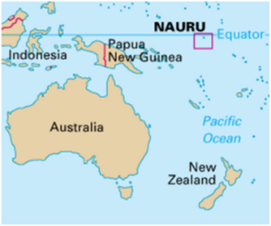 |  | 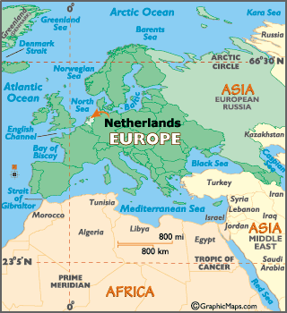
Mexico | Nauru | Nepal | Netherlands
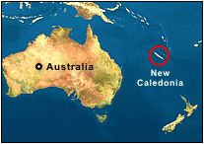 | 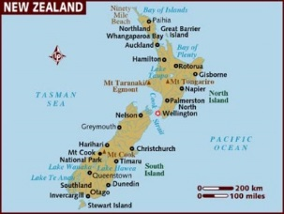 | 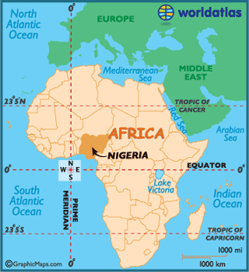
New Caledonia (France) | New Zealand | Nigeria | Nonreligious

Mandarin  955 million | Malaysia  30,580,300 | Malay/ Indonesian  77 million | Macedonia  2,065,769
Netherlands  16,902,100 | Nepal  28,037,904 | Nauru  10,084 | Mexico  121,005,815
Nonreligious  1.1 billion | Nigeria  183,523,000 | New Zealand  4,581,600 | New Caledonia (France)  268,767

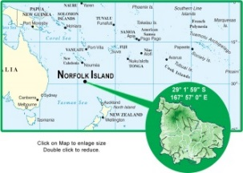 | 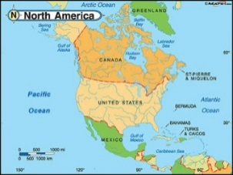 | 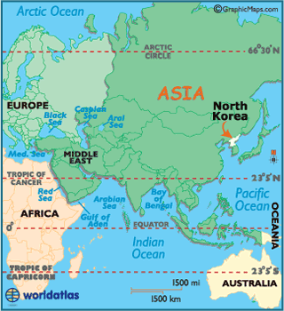 | 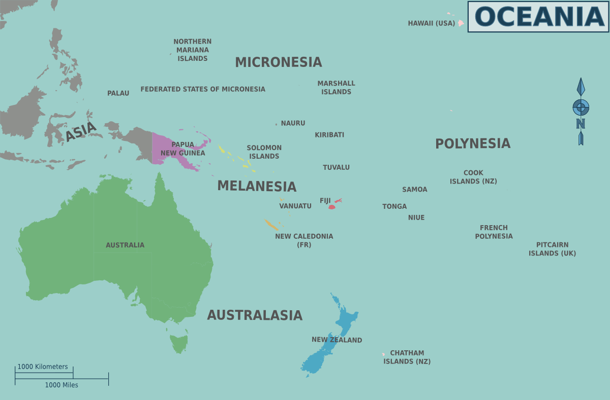
Norfolk Island (Australia) | North America | North Korea | Oceania
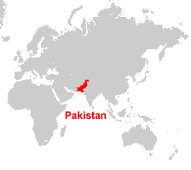 | 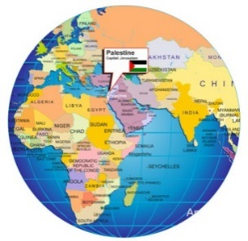 | 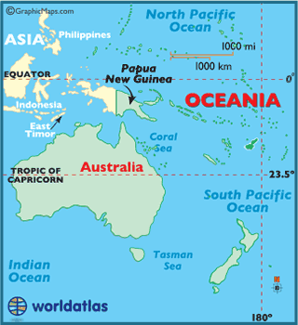
Pakistan | Palestine | Papua New Guinea | Persian
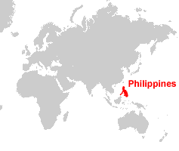 | 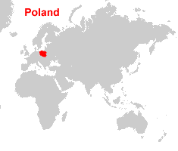 | 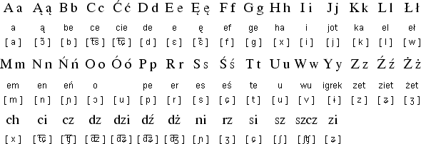 | 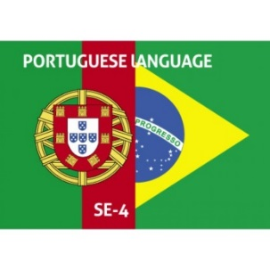
Philippines | Poland | Polish | Portuguese

Oceania  38 million | North Korea  25,155,000 | North America  565 million | Norfolk Island (Australia)  2,302
Persian  65 million | Papua New Guinea  7,398,500 | Palestine  4,682,467 | Pakistan  189,772,000
Portuguese  215 million | Polish  40 million | Poland  38,484,000 | Philippines  101,434,900

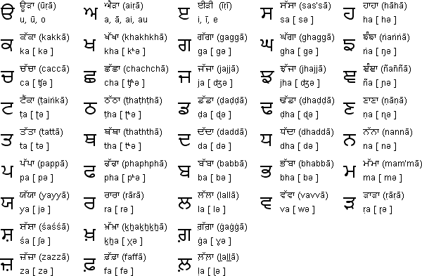 | 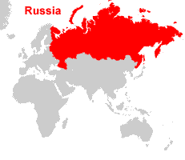 | 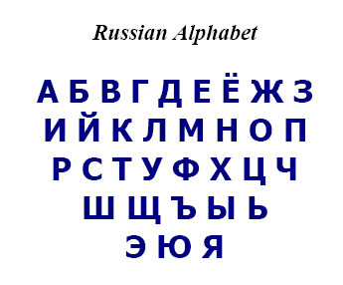 | 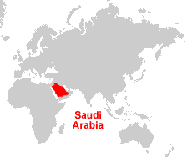
Punjabi | Russia | Russian | Saudi Arabia
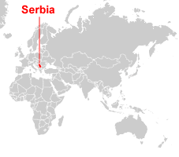
Serbia | Shinto | Sikhism | Singapore
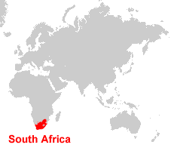 | 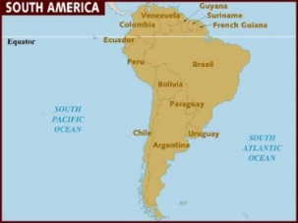 |  | 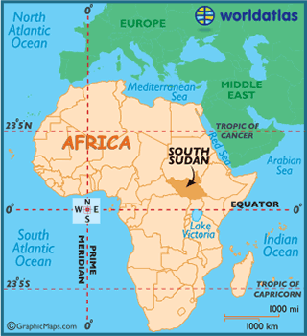
South Africa | South America | South Korea | South Sudan

Saudi Arabia  31,521,418 | Russian  155 million | Russia  146,267,288 | Punjabi  102 million
Singapore  5,469,700 | Sikhism  23 million | Shinto  4 million | Serbia  7,146,759
South Sudan  11,892,934 | South Korea  51,342,881 | South America  406 million | South Africa  54,002,000

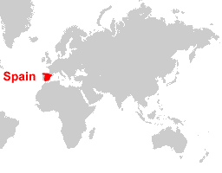 |  | 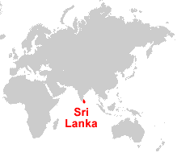 | 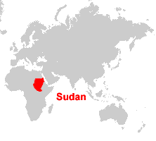
Spain | Spanish | Sri Lanka | Sudan
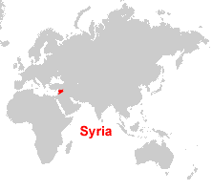 |  |  | 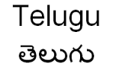
Syria | Taiwan | Tamil | Telugu
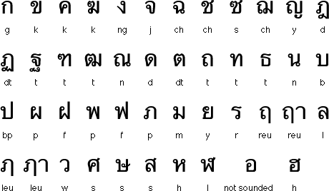 | 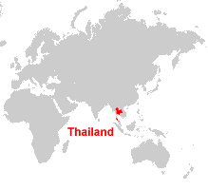 | 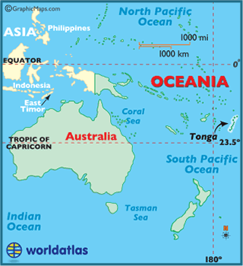 | 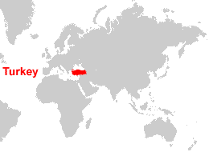
Thai | Thailand | Tonga | Turkey

Sudan  38,435,252 | Sri Lanka  20,675,000 | Spanish  405 million | Spain  46,464,053
Telugu  76 million | Tamil  70 million | Taiwan  23,452,387 | Syria  23,190,655
Turkey  77,695,904 | Tonga  103,252 | Thailand  65,104,000 | Thai  56 million

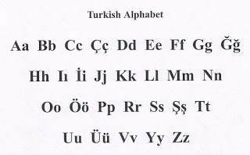 | 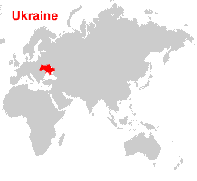 | 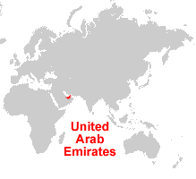 | 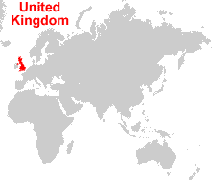
Turkish | Ukraine | United Arab Emirates | United Kingdom
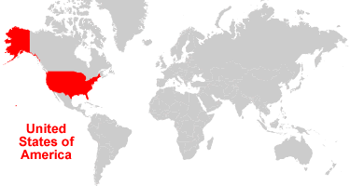 | 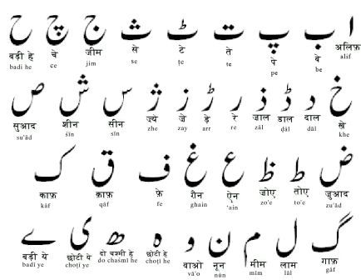 |  | 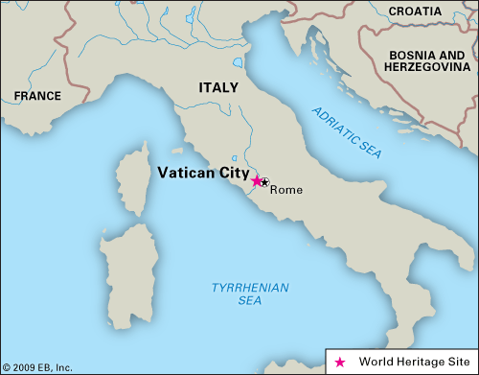
United States | Urdu | Vanuatu | Vatican City
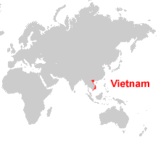 |  |  | 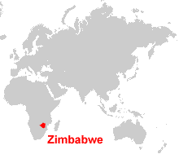
Vietnam | Vietnamese | World | Zimbabwe

United Kingdom  64,800,000 | United Arab Emirates  9,577,000 | Ukraine  42,895,704 | Turkish  63 million
Vatican City  839 | Vanuatu  264,652 | Urdu  66 million | United States  320,986,000
Zimbabwe  13,061,239 | World  7.2 billion | Vietnamese  76 million | Vietnam  91,583,000

