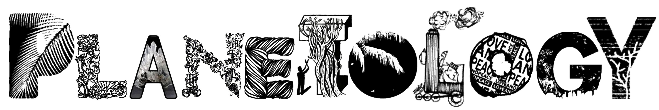
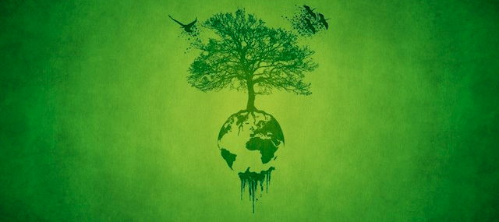

HANDBOOK

LIFE IN MAYA
Maya is a large country with a population of around 200,000. For centuries it has been a naturally blessed place to live, with a large abundance of plants and animals, living in harmony with humans. In the past fifty years however, humans have increased in population, meaning they have had a larger and larger footprint on the natural systems of Maya. Groups that once lived in harmony together now battle for ever dwindling natural resources. The once abundant landscape is now threatened by numerous threats, both pressing and long term. Your challenge is to assume the roles of the people of Maya and meet the many challenges that await, while coping with difficult circumstances as they arise. You will need all your creative thinking, problem solving, communication, negotiation and research skills to save Maya!

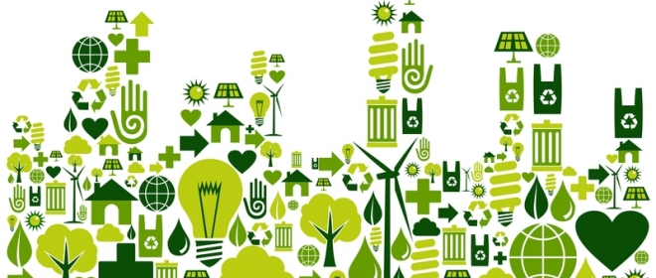
SAVING MAYA

To win the game of Planetology and save Maya, you must:

- Solve all Planet Challenges
- Have at least 100% water quality
- GHGs must be below 400PPM
- Deal with the lack of biodiversity. Biodiversity starts at 62 species, and by the end of the game it can’t be any lower than 40 species
- Have no outstanding circumstances that haven’t been dealt with
- There must still be money left in the game, i.e. adding up all cash and debt, this must be above zero.

How do you win? Who knows! That is up to you. All we can suggest is that a combination of creative thinking, inventions, policies, treaties, trading and research might get you some of the way there.

SOLVING PLANET CHALLENGES

Each role has Planet Challenges. To solve a Planet Challenge you must present your solution on your turn. Fate will decide whether your suggested solution is enough to solve the challenge. A few ways to solve Planet Challenges include inventions, new policies and contracts.

Inventions
Fate has blank invention forms. To invent something, you must write the name of the invention, what it does, and draw a picture of it. Fate will then decide whether it is allowed, and how much it will cost.

Policies
A policy is a rule or law that a role might put into place. The president holds blank policy forms. To make a new policy, show it to the President and they will decide whether or not it is allowed. Policies can only be made by the government or by one group that has power over another.

Contracts
A contract is a deal made between two or more groups, outlining some agreement. To make a contract, make up a name for the contract, what it means, what will happen if someone breaks the contract, get all parties to sign it, then show it to a member of the government who will decide if it is okay and then will sign off on it. Contracts are between any groups who are equals.

All Planet Challenges are represented by a piece on the board. Once you solve a Planet Challenge, you must change the board in some way to represent it being solved. The Planners will make pieces if needed.

THE PROCESS

OF THE GAME

Everyone will be put into groups. You will have a list of your Planet Challenges. You will then place the piece that represents each Planet Challenge on the board. The process then goes like this:

- Open negotiation
- Industry turn (transport, oil, mining, tourism)
- Open negotiation
- Primary producers (farmer, logger, grower, fisher)
- Open negotiation
- Planners (Civil engineer and developer)
- Open negotiation
- NGOs (Public Alliance and Green Ninjas)
- Open negotiation
- Citizens (Young, Old, Indigenous)
- Open negotiation
- Bank
- Open Negotiation
- Government (President, Secretary of Commerce, Environment Minister)
- Open Negotiation
- Fate can say anything if they want

Each group’s turn cannot last longer than five minutes. If it does, they must end their turn immediately and pay the Vault a $200,000 fine.

Note that when it is your turn, you are just there to take actions, then get a circumstance and an income card. You must have already decided what you are going to do before it is your turn.

What to do on your turn:

- Say “I’m _____, and I’m the ______, and these are my actions:”
- Take any actions (e.g. table a contract, build invention, release new policy…)
- Take an income card
- Take a circumstances card

What to do when it is your turn next
- Have any actions ready to do, for example:
  - have contracts ready to table
  - have invention forms ready to submit
  - have new pieces ready to put on the board, or be ready to change / move existing ones

GROUPS AND ROLES
There are 7 groups. Some of the groups are further divided into roles within that group. It is up to your group if you share all the roles or assign a role to a specific person.

- Primary Producers
  - Farmer
  - Grower
  - Logger
  - Fisher
- NGOs
  - Green Ninjas
  - Public Alliance
- Planners
  - Civil Engineer
  - Developer
- Industry
  - Energy
  - Mining
  - Tourism
  - Transport
- Citizens
  - Old
  - Young
  - Indigenous
- Government
  - President
  - Environment Minister
  - Secretary of Commerce
- Banker
- Fate

Each role has a number of Planet Challenges that need to be solved. Your group as a whole is responsible for all the roles within your group. Your group will also have a job that needs to be done by someone in your group.

Fate is a special role that helps run the game, and doesn’t play the game the same way others do. Fate gets given an extra set of secret information.

INITIAL CONDITIONS

STARTING WEALTH
- Primary producers $14,000,000
- NGOs $4,000,000
- Planners $8,000,000
- Industry $14,000,000
- Citizens $7,000,000
- Bank $20,000,000
- Government $12,000,000

ENVIRONMENTAL CONDITIONS
- Air and water purity start at 100%
- GHGs start at 400ppm
- Biodiversity starts at 62

FORMS
Form | Purpose | Who to give it to
Contract | Creates an agreement between two roles, which has negative consequences if broken | Government must sign then you keep it
Policy | Creates a rule that applies to people under the command of whoever makes the policy | President must sign then you keep it
Invention | Show what a new invention does and how much it costs to make | Fate puts price on it then you keep it

