Find two different things about the same length | Find three different things about the same length
Find one thing longer and one thing shorter than your pencil | Your team must stand in order from tallest to shortest
How many pencils long is your table? | How many feet wide is the bottom of the door?
How many hands wide is the whiteboard? | How many hands wide is your table?
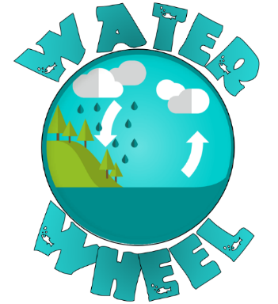  LENGTH | LENGTH
LENGTH | LENGTH
LENGTH | LENGTH
LENGTH | LENGTH

How many centimetres long is your pencil? | How many centimetres long is your handspan?
How many centimetres long is your shoe? | Find something 10 cm long.
Find something 20 cm long. | Find something 30 cm long.
How long is the river that goes from the lake to the ocean? | How long from the seal to the penguin?
LENGTH | LENGTH
LENGTH | LENGTH
LENGTH | LENGTH
LENGTH | LENGTH

How many handspans around the board? | How many cm around the board?
Which snake is longest? | Find something 5cm long.
Find something 15 cm long. | Find something 25 cm long.
How many hands high is your chair seat?
LENGTH | LENGTH
LENGTH | LENGTH
LENGTH | LENGTH
LENGTH | LENGTH

